Globalize Your Standards  There are many different types of resources available to help you globalize your standards. This list includes a variety of sources of inspiration, including global ed curriculum, projects, virtual field trips, global films, and video conferences with global speakers.  Resources:  - Primary Source  - Learn Around the World  - Skype a Scientist  - Global Oneness Project  - Out of Eden  - Project Explorer  - Reach the World  - Journeys in Film  - National Geographic Explore Classroom  - Google Arts and Culture  - U.S. History in a Global Context  - FANschool  - Skype Virtual Field Trips  - Skype Guest Speakers | Globalize Your Community  Environment matters. Culture matters. Leadership and vision matter. What else? As an advocate for global education, you can build your capacity and impact your community with the ideas in the items below. Enjoy!  Resources:  - 5 Best Ways to Globalize your School  - 6 Ways to Globalize your School  - Global Schools - Australia  - Creating Meaningful Global Connections  - Getting Schools Ready for the World  - Schools Can Go Global  - Taking Schools to the Next Level  - Developing a Global Learning School  - 21st Century Administrators: Leading Globally-Minded Districts  - NC Global Education: Students Ready for the World
Globalize Your Standards: Inquiry Approach  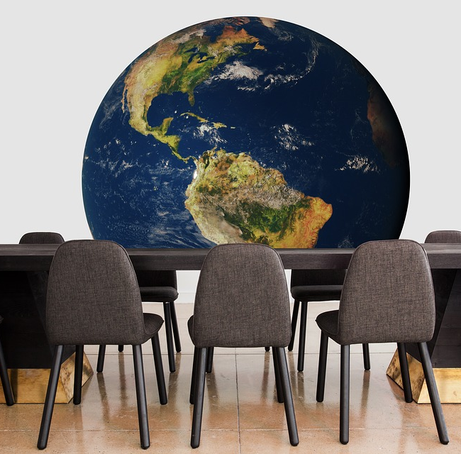  Inquiry based education is a great way to globalize your standards. Ask a question that is global is scope, impact, and perspective, and you have made a large step towards global education.  Resources:  - C3 unit on Global Citizenship (1st Grade)  - C3 unit on Geography and Human Interaction (2nd Grade)  - C3 unit on Globalization (3rd Grade)  - C3 unit on Religious Freedom (6th Grade)  - C3 unit on Fair Trade (Grades 9-12)  - C3 unit on the UN and Genocide (Grades 9-12)  - C3 unit on the Internet (12th Grade)  - Using Inquiry Modules for Global Education - Blog  - Did We Overcome Racism Yet - Blog  - Who Cares? Writing Inquiries that are Worthwhile | Connecting Local and Global Communities  How can you connect your students to their global peers as part of globalizing your standards? These programs will facilitate your global connections and relationships.  Resources:  - The Wonderment  - Generation Global (ages 12 - 17)  - Belouga  - iEarn  - Mystery Skype  - Travelling Teddy Bear  - Around the World with Abu Abed  - ePals  - PenPal Schools  - Technology Ideas & Tools to Connect Students to the World  - Flat Stanley Project  - Empatico (ages 8-10)  - Global Scholars (part of Global Cities) (ages 10-13)  - International Virtual Schooling (IVECA)

