Social Justice in Algebra – Linear Functions and the Syrian Refugee Crisis
Leave photo on projector as students enter the room. Have whiteboards on the desk, as well as a pillowcase. Instruct them that a war has broken out and they have three minutes to pack and flee their homes. They will have to travel 150 miles by foot to safety for an undetermined about of time—possibly years-- so they can only carry what will fit in a pillowcase and be manageable in weight. Students record on the whiteboard the items they would choose to take. Think-pair-share this activity, and then share out as a class. Ask them how they felt about making those kinds of decisions.
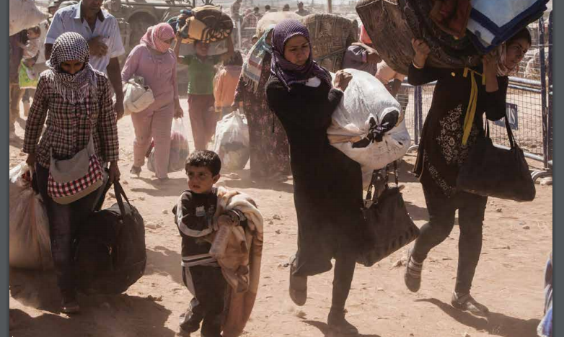
Ask students if they have heard about the migrant/refugee crisis. If so, what stories have they come across in the media? Explain that refugees usually travel light and take one bag with them as they flee their homes.
Ask students if they know the difference between a refugee and a migrant. Explain that a migrant is an individual who chooses to leave his or her home country for any number of reasons, such as for a job or other opportunities. A refugee is someone who is fleeing armed conflict—like the civil war in Syria—or persecution, such as the Jewish people who fled Germany during the Holocaust.
Read the following as a class and discuss the mathematics in the statement, as well as the trend of the data.
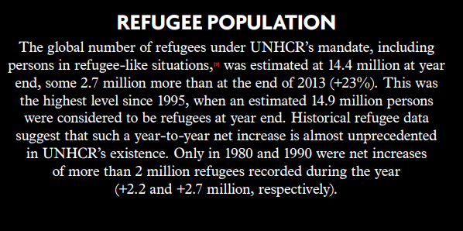
The United States is considered to be a country that has, historically, welcomed refugees. Between 1975 and 2007, the U.S. took in approximately 2.5 million refugees.* Compare that number to the more than one million migrants and refugees who sought entry into Europe in 2015 alone.
Explain that a majority of refugees and migrants are coming from Syria, Afghanistan, Iraq, and other countries in the Middle East. They are hoping to find a safe way to travel to Northern Europe. Show students a map of the Middle East and Europe, identifying the proximity of Syria and Croatia. Explain to students that the number of refugees leaving the Middle East is higher than it's ever been, primarily due to the civil war in Syria and ongoing conflicts in Iraq and Afghanistan. Explain that today we will focus on the refugees fleeing the country of Syria and examining what the trend of the data shows us and how we can use that data to predict the future.
First, where is Syria in the world? (Map)
Key questions to consider and take notes on while watching the video explaining the crisis in Syria:
- Why are people fighting? Who is fighting?
- What might it be like to live in a country during a war?
- Which countries are people fleeing to, and why those countries?
- What might it be like to have thousands or hundreds of thousands of new people in our city or country?

Syrian Crisis Explained:
https://www.youtube.com/watch?v=JFpanWNgfQY
Potential second video resource:
https://www.facinghistory.org/resource-library/video/overview-refugee-crisis
Guiding question: “Given the number of Syrian refugees who have entered Turkey each month for the past 12 months, how many refugees can Turkey expect to support by the end of 2017?”
Give each student a copy of the data, as well as a graph that is already set up. Pull up the data from the UNHCR Report and discuss the work of the UN to compile the data and what makes it credible.
http://www.unhcr.org/556725e69.html#_ga=1.30225276.2132664891.1441306986
Resource with data needed to answer the question:
http://data.unhcr.org/syrianrefugees/country.php?id=224
Data presented in a readable Google Spreadsheet:
https://docs.google.com/spreadsheets/d/1wkx10TaU8Br_P27wxi7PZgOzmc93g8Ogxrfuo3UHPNI/edit#gid=1210751218
Using the preprinted graph, work as a class to structure the axes and plot the given data. Interpret individual points, as well as the rate of change, and use that information to find the y-intercept and describe what it means in context. Use the information to create a linear function and use the data to predict how many refugees we may have in the world by the time they graduate from high school.
Analyze the data and come up with an answer to the proposed question.
- What assumptions did you make in finding your answer? What might change about your answer if your assumption was wrong?
- How do we know if an answer is “reasonable” or “makes sense”? Based on your answer, what might it feel like to have this many new people in your country?
- What factors might decrease or increase the rate of Syrian refugees entering Turkey?
- What can students do? What are some ways that they can help in the refugee crisis?
Homework: Each student will analyze the given graph and state two “notices” and two “wonders” to share with each other the following day. They may need to look up words or do some research. If so, make a note of sources or websites that were utilized to obtain further information.
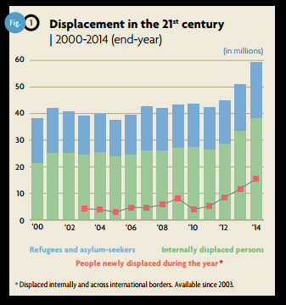
Show the Video on refugees from around the world:
http://www.unhcr.org/globaltrends2016/
Ask students to partner up to share what they learned from the graph given to them as HW. Think-pair-share with four people in a group and then have each group share their learnings with the class.
Brainstorm about ways they can get involved in solving this global problem and how they can create awareness among their peers. Share with them the idea of using Instagram and working together to improve our global awareness as a local community.
Share with the students about the first ever refugee Olympic Team in 2016, and what is says about the potentially new state of our world.
http://www.unhcr.org/en-us/news/latest/2016/8/578e20187/countdown-rio-2016-refugee-olympic-team-prepares-historic-debut.html
Photos of migration:
https://www.globalonenessproject.org/library/photo-essays/crossing-borders#photo=1
Extra Video Resources:
“Syria’s War: Who Is Fighting and Why”
“Explain Like I’m Five: The Crisis in Syria”
“The European Refugee Crisis and Syria Explained”
“Syrian Refugees Explain Why They Fled Syria”

